*Florida International University*

*School of Computing and Information Sciences*

Software Engineering Focus

Final Deliverable

Keeping Mothers and Infants Healthy

**Team Members:** Andy Herrera, Arelys Alvarez

**Product Owner**: Jean Hannan

**Instructor**: Masoud Sadjadi

The MIT License (MIT)

Copyright (c) *2016 Florida International University*

Permission is hereby granted, free of charge, to any person obtaining a copy of this software and associated documentation files (the "Software"), to deal in the Software without restriction, including without limitation the rights to use, copy, modify, merge, publish, distribute, sublicense, and/or sell copies of the Software, and to permit persons to whom the Software is furnished to do so, subject to the following conditions:

The above copyright notice and this permission notice shall be included in all copies or substantial portions of the Software.

THE SOFTWARE IS PROVIDED "AS IS", WITHOUT WARRANTY OF ANY KIND, EXPRESS OR IMPLIED, INCLUDING BUT NOT LIMITED TO THE WARRANTIES OF MERCHANTABILITY, FITNESS FOR A PARTICULAR PURPOSE AND NONINFRINGEMENT. IN NO EVENT SHALL THE AUTHORS OR COPYRIGHT HOLDERS BE LIABLE FOR ANY CLAIM, DAMAGES OR OTHER LIABILITY, WHETHER IN AN ACTION OF CONTRACT, TORT OR OTHERWISE, ARISING FROM, OUT OF OR IN CONNECTION WITH THE SOFTWARE OR THE USE OR OTHER DEALINGS IN THE SOFTWARE.

***Abstract***

*This document presents the information necessary to gain a good understanding of the background, necessity, technology used, effort put into the creation of the first version of the Keeping Moms and Infants Healthy app.*

*The creation of this app will help low income mothers find more information on their health, child, and pregnancy. The application will provide language support in 3 options (English, Spanish & Creole) and will offer a safe place to learn about sexual education. Low income mothers will be able to find local programs for prenatal and postnatal care, mothers will have the opportunity to set up notifications to remind them of important details about their child or pregnancy. All these features will facilitate the user be up to date and informed on all matters related to delivering a healthy baby while staying safe themselves.*

**Table of Contents**

**Introduction** ………………………………………………………………………………………………………………..…….... 5

Current System ……….…………………………………………………………………………………………………..……. 5

Purpose of New System ………………………….……………………………………………..…………………...………. 5

**User Stories**

Implemented User Stories …………………………………...………………………….…………………………………. 7

Pending User Stories …………………………………………………………………...………………………………...….. 10

**Project Plan**

Hardware and Software Resources ………………………………………………………………..………………..… 12

Sprints Plan ……………………………………………………………..…………………………………………………….…. 13

*Sprint 1*  ……………………………………………………………………………………………………………………..….... 13

*Sprint 2*  …………………………………………………………………………………………………………………..….…... 13

*Sprint 3*  …………………………………………………………………………………………………………………...……... 14

*Sprint 4*  …………………………………………………………………………………………………………………………... 15

*Sprint 5*  …………………………………………………………………………………………………………………………... 16

*Sprint 6*  …………………………………………………………………………………………………………………………... 17

*Sprint 7*  …………………………………………………………………………………………………………………………... 18

**System Design**

Architectural Patterns …………………………………………………………………………………………………….. 20

System and Subsystem Decomposition ………………………………………………………………………….…….… 21

Deployment Diagram ……………………………………………………………………………………………..……….…... 22

Design Patterns …………………………………………………………………………………………………………….….... 22

**System Validation**  ………………………………………………………………………………………………………………….23

**Glossary**  …………………………………………………………………………………………………………………..…………….37

**Appendix**  ……………………………………………………………………………………………………………………..………….38

Appendix A - UML Diagrams …………………………………………………………………………………………………. 38

*Static UML Diagrams*  ……………………………………………………………………………………………………….38

*Dynamic UML Diagrams*  …………………………………………………………………………………………………..40

Appendix B - User Interface Design …………………………………………………………………………...…….…... 52

Appendix C - Sprint Review Reports ………………………………………………………………………………...…… 69

Appendix D - User Manuals, Installation/Maintenance Document, Shortcomings/Wishlist Document and other documents …………………………………………………………………….……………….…… 74

**References** …………………………………………………………………………………………………………………...………...80

# Introduction

Keeping moms and infants healthy is a smartphone-based maternal/infant healthcare application (app), in 3 languages (English, Spanish & Creole), designed for low-income minority mothers. An APP to be developed to provide early and continued access to health care for prenatal and postnatal mothers that contains useful features.

The features available would be weekly information on pre/postpartum health via text message notifications to the phone. Information on infant care through provided resources. Guidance in navigating the health care system through provided forms and resources on where to find more information. Resources on breastfeeding and locations where class can be taken along with parenting classes, childcare, and tours of hospitals for childbirth. Nurse practitioner contact information for getting in touch with a professional through the app. Clinic locations and services that are provided in such clinics. Since the application is directed to low income women all the resources available within the app will be free of cost.

The app was developed through a Facebook framework called React Native. This framework gave the opportunity to create the app in a way that could be converted into native Android and Apple components. Thus, the app could be tested and used on both Android and Apple devices. React Native libraries where used to make all the features in the app and provide the final product. Firebase was used as the database to authenticate and store the user’s information for profile creation.

## Current System

This is the current system as it is version 1.0 of the Keeping Moms and Infants Healthy application.

## Purpose of New System

The purpose of this system is to bring all the features described by the Product Owner into the application for both Android and Apple users while keeping the requirements asked for.

This new system has the following requirements:

* English, Spanish, Creole language support
* Medical Information available
* Prenatal and Postnatal care information
* Local programs available
* Sexual Education Information
* Local clinics and Nurse Practitioners to contact
* Profiles with user information and the ability to upload photos/documents
* UI that is easy to use and understand
* Easy and intuitive navigation system
* Tutorial slides to show how the app works

# User Stories

The following section provides the detailed user stories that were implemented in this iteration of the Keeping Mothers and Infants Healthy project. These user stories served as the basis for the implementation of the project’s features. This section also shows the user stories that are to be considered for future development.

## Implemented User Stories

|  |  |
| --- | --- |
| 29 | Wireframe |
| 30 | Set up environment |
| 34 | Link to health resources |
| 39 | Set Up Database |
| 43 | Skeleton for the project |
| 49 | Project Outline |
| 54 | Authentication |
| 55 | Profile Creation |
| 61 | Reorganize wireframe |
| 67 | CDC API |
| 76 | Language Requirement |
| 79 | Add Functionality to Documents View |
| 81 | Continue Backend Part of Authentication Process |
| 82 | Push sign up information to the database |
| 86 | Add User Photo to Profile Creation |
| 92 | Review and reorganize the work |
| 95 | Finish last details of authentication and sign in |
| 98 | Figure out a way to retrieve user information from the database |
| 108 | Add classes screen and functionality |
| 109 | Add clinics screen and functionality |
| 119 | Redo navigation |
| 123 | Continue fixing navigation |
| 124 | Finalize clinics screen |
| 127 | Perfect UI design of the app |
| 131 | Home page functionality |

## Pending User Stories

|  |  |
| --- | --- |
| 131 | Send and retrieve user info to and from the database |
| 132 | Can store and retrieve documents in database |
| 133 | Access documents from phone drives |
| 134 | Create signup option for nurse practitioners |
|  |  |

# Project Plan

This section describes the planning that went into the completion of this project. This project incorporated the Agile development methodology and as such required the Sprints to be planned. These Sprint planning’s are detailed below. This section also describes the components, both software and hardware, chosen for this project.

## Hardware and Software Resources

The following is a list of all hardware and software resources that were used in this project:

OS Name Microsoft Windows 10 Home

Version 10.0.18362 Build 18362

MacBook Air 13-inc

OS: MacOS Mojave Version 10.14.3

Processor: 2.2 GHz Intel Core i7

Memory:  8GB 1600 MHz DDR3

Graphics: Intel HD Graphics 6000 1536 MB

Visual Studio Code: source-code editor

Figma: cloud-based design tool

Photoshop CC 2020: photo editor

iPhone 8 Plus

Model Number MQ902LL/A

Android Studio Android Emulator

Pixel 2 XL API 28

iPhone 8 Plus

Model Number MQ922LL/A

## Sprints Plan

### Sprint 1

**Story ID**: 49

**Feature**: Project Outline

**Description**: As a developer, I would like to make a project outline, so I'm better organized to work on the project

**Acceptance criteria**:

* Verify that the project outline is properly created
* Verify that we meet with the project owner and we understand her idea

**Story Points**: 5

**Story ID**: 43

**Feature**: Skeleton for project

**Description**: As a developer, I want to have a skeleton for the project, so I can have all my work properly organized.

**Acceptance criteria**:

* Verify that skeleton is successfully created

**Story Points**: 15

**Story ID**: 30

**Feature**: Setup Environment

**Description**: As a developer, I want to set up the environment so I can start working on the app.

**Acceptance criteria**:

* Verify that the repo for the project is correctly created
* Very that the correct configuration for ci/cd is done

**Story Points**: 25

**Story ID**: 29

**Feature**: Wireframe

**Description**: As a developer, I want to design a wireframe for the app, so I can have a general idea of how the app would look like

**Acceptance criteria**:

* Verify that all features are included in the wireframe

**Story Points**: 5

### Sprint 2

**Story ID**: 61

**Feature**: Reorganize wireframe

**Description**: as a developer I want to continue reordering my wireframes so I can have a better idea of how the app would look like.

**Acceptance criteria**:

* Verify that all the features are included in the wireframe

**Story Points**: 20

**Story ID**: 67

**Feature**: CDC API

**Description**: As a developer, I want to explore the CDC API to render data for the app in a speedy manner.

**Acceptance criteria**:

* Verify that the API can be used
* Verify that the API is working as expected

**Story Points**: 10

**Story ID**: 54

**Feature**: Authentication

**Description**: As a user, I want to be able to authenticate, so no one else is able to see my info in the app

**Acceptance criteria**:

* Verify that the user can authenticate themselves successfully

**Story Points**: 20

**Story ID**: 30

**Feature**: Set up environment

**Description**: As a developer, I want to set up the environment, so I can start working on the app.

**Acceptance criteria**:

* Verify that the repo for the project is correctly created
* Very that the correct configuration for ci/cd is done

**Story Points**: 25

**Story ID**: 39

**Feature**: Set up database

**Description**: As a developer, I want to design and create a database, so all the information I'm displaying in the app is organized and easy to access

**Acceptance criteria**:

* Verify that the design is efficient
* Very that the database is organized

**Story Points**: 15

**Story ID**: 55

**Feature**: Profile creation

**Description**: As a user, I can create an account and manage it, so my information is accurate and editable.

**Acceptance criteria**:

* Verify that the user can create an account
* Verify that the user can edit the account information

**Story Points**: 20

### Sprint 3

**Story ID**: 86

**Feature**: Add user photo to profile creation

**Description**: As a user, I can upload a photograph of myself to my profile so that it can feel more personal.

**Acceptance criteria**:

* Verify that a photo can be taken from the camera.
* Verify that a photo can be taken from the phone gallery.
* Verify that the photo will be a circle shaped.

**Story Points**: 10

**Story ID**: 82

**Feature**: Push sign up info to database

**Description**: As a developer I want to have the user's information stored in my database, so all the data is better organized.

**Acceptance criteria**:

* Verify that once the user signs up their information is sent to the database successfully
* Verify that once the user signs up they can access their data within the app

**Story Points**: 20

**Story ID**: 81

**Feature**: Continue Backend Part of Authentication Process

**Description**: As a user, I want to be able to log in in the app, so I'm sure my information is protected

**Acceptance criteria**:

* Verify that the authentication is correctly implemented
* Verify that the user is able to authenticate successfully

**Story Points**: 15

**Story ID**: 76

**Feature**: Language Requirement

**Description**: As a user, I want to select the language I want so that I can understand the application.

**Acceptance criteria**:

* Verify that the user can select the language of their preference
* Verify that the user has the option to change the language on their profile
* Verify that the information is displayed in the selected language

**Story Points**: 15

**Story ID**: 34

**Feature**: Link to health resources

**Description**: As a user, I want a section in the app to see the links for health resources, so I can be more informed about sexual education.

**Acceptance criteria**:

* Verify that the external links works properly
* Verify that links are displaying correctly

**Story Points**: 25

### Sprint 4

**Story ID**: 98

**Feature**: Figure out a way to retrieve user information from the database

**Description**: As a developer, I want to be able to store user data in the database for easy access within the app.

**Acceptance criteria**:

* Verify that the information is received in the database
* Verify that the information is displaying correctly
* Verify that the information can be accessed easily and effective

**Story Points**: 10

**Story ID**: 95

**Feature**: Finish last details of authentication and sign in

**Description**: As a user, I want to be able to authenticate without problems so I can have my information protected.

**Acceptance criteria**:

* Verify that error handling is working properly
* Verify that once the user is authenticated, they can go directly to the landing page

**Story Points**: 15

**Story ID**: 92

**Feature**: Review and reorganize the work

**Description**: As a developer, I want to be able to organize my work in a way that is easy to understand so I don't get lost when the complexity of the app increases.

**Acceptance criteria**:

* + Verify that there is no repetitive code
  + Verify that every time possible components have been used
  + Verify that style is consistent

**Story Points**: 50

### Sprint 5

**Story ID**: 119

**Feature**: Redo navigation

**Description**: As a developer, I want to redesign the navigation, so it is easier for me to continue developing more complicated features.

**Acceptance criteria**:

* + Verify that icons are displaying correctly
  + Verify that the new navigation system is easy to use and understand
  + Verify that the language feature works with the new navigation structure

**Story Points**: 10

**Story ID**: 98

**Feature**: Figure out a way to retrieve user information from the database

**Description**: As a developer, I want to be able to store user data in the database for easy access within the app.

**Acceptance criteria**:

* + Verify that the information is received in the database
  + Verify that the information is displaying correctly
  + Verify that the information can be accessed easily and effective

**Story Points**: 10

**Story ID**: 109

**Feature**: Add clinics screen and functionality

**Description**: As a developer, I want to add a map that shows the available clinics so the user can know where they are and how to contact them.

**Acceptance criteria**:

* + Verify that the map is showing in the screen
  + Verify that the clinics icons are correctly place and displayed
  + Verify that while the component is loading there is a loading a screen informing the user what’s happening
  + Verify that the nurse icon is displayed on the left top corner of map

**Story Points**: 25

**Story ID**: 108

**Feature**: Add classes screen and functionality

**Description**: As a developer, I want to add a classes screen where the user can find information on local program, they can attend so they can stay informed on their pregnancy or child rearing.

**Acceptance criteria**:

* + Verify that the icons are placed in the correct location
  + Verify that Models can be used to display the information needed
  + Verify that a JSON file can be used to store the necessary data

**Story Points**: 25

**Story ID**: 79

**Feature**: Add functionality to documents view

**Description**: As a user, I want to add documents and delete them from the app so that it can hold important information for when I need it.

**Acceptance criteria**:

* Verify that documents can be organized
* Verify that a user can add documents
* Verify that a user can delete documents

**Story Points**: 25

### Sprint 6

**Story ID**: 131

**Feature**: Home page functionality

**Description**: As a user, I want to have financial documents available to view on the app for the purpose of being informed.

**Acceptance criteria**:

* + Verify that the links work properly
  + Verify that the design for presenting the information is legible
  + Verify that the language feature is supported

**Story Points**: 20

**Story ID**: 127

**Feature**: Perfect UI design of the app

**Description**: As a user, I want to improve the current design of the app, so the user has a better experience accessing it.

**Acceptance criteria**:

* + Verify that the components are aligned properly
  + Verify that the Sex Education bugs are fixed and that language notifications are shown
  + Verify that the translation bugs and errors are fixed
  + Verify that the color combination is legible and appropriate
  + Verify that the style combines with the audience to which the app is directed

**Story Points**: 15

**Story ID**: 124

**Feature**: Finalize clinics screen

**Description**: As a user, I want to improve the clinics screen so the user can access available clinics without bugs or delays.

**Acceptance criteria**:

* Verify that the clinics screen delay is appropriate (10 seconds)
* Verify that the bottom navigation and header fit the screen
* Verify that the user can navigate from the clinics screen to the add nurse info screen
* Verify that pins are added in the locations of the clinics

**Story Points**: 20

**Story ID**: 123

**Feature**: Continue fixing navigation

**Description**: As a user, I want to fix the navigation system so the user can have an improved UI and functionality.

**Acceptance criteria**:

* Verify that navigation bugs are fixed
* Verify that the active screen is showing in the bottom tab navigation
* Verify that sign in and sign out functionality are working as expected

**Story Points**: 25

**Story ID**: 108

**Feature**: Add classes screen and functionality

**Description**: As a developer, I want to add a classes screen where the user can find information on local program, they can attend so they can stay informed on their pregnancy or child rearing.

**Acceptance criteria**:

* + Verify that the icons are placed in correct location
  + Verify that Models can be used to display the information needed
  + Verify that a JSON file can be used to store the necessary data

**Story Points**: 25

**Story ID**: 79

**Feature**: Add functionality to documents view

**Description**: As a user, I want to add documents and delete them from the app so that it can hold important information for when I need it.

**Acceptance criteria**:

* Verify that documents can be organized
* Verify that a user can add documents
* Verify that a user can delete documents

**Story Points**: 25

**Story ID**: 30

**Feature**: Setup Environment

**Description**: As a developer, I want to set up the environment so I can start working on the app.

**Acceptance criteria**:

* verify that the repo for the project is correctly created
* very that the correct configuration for CI/CD is done

**Story Points**: 25

# System Design

This section contains information on the design decisions that went into this project. We used a simple and easy to use application design to help the user to understand the application, as well as a simple architecture design so is better for the developers to understand the overall flow of the app. The architecture patterns are outlined and explained below. The entire system is shown in a package diagram and the subsystems are explained. Finally, the design patterns used in the project are discussed.

## Architectural Patterns

The pattern that was applied when architecting the application was the model-view-controller pattern also known as MVC controller. With the use of this model the application was divided into 3 parts as shown below:

view — displays the information to the user (the UI)

controller — handles the input from the user

model — contains the core functionality and data

This model was used to separate the internal representations of information from the way that the information is presented to, and accepted from, the user. This pattern permits to decouple components and allows efficient code reuse within the application.

handle user input

user interaction

Controller

View

notifies changes

query model

update

model

Model

## System and Subsystem Decomposition

The system and subsystem deposition can be referenced to as a way to understand better how the application is structured. The application is divided in 5 main folders: views, components, constants, context and function. The views are what the user interacts with (UI), the components are the models that permit the reuse of such components within the application, the constants are the configuration files that stay the same through their use within the app, the context is where all the handling between the views and the functions happen and lastly the functions are the Google Cloud functions that handle the user creation and auth process.





Components

Functions

Context

Views

Constants

## Design Pattern

**Alongside the MVC design pattern we also used a state design pattern. This pattern** encapsulates the various states that the application can have and allows the objects to alter its behavior when its internal state changes. The system or the context, as it is known in pattern-speak, can have actions taken on it that drive it into different states. The use of this design allows the code to be more flexible and concise.

# System Validation

|  |  |
| --- | --- |
| Case ID | Create user |
| Purpose | Validate the user creation process |
| Preconditions | User has a valid phone number |
| Expected results | User can create a personal account and subsequently sign in into the app with the account created. |

|  |  |
| --- | --- |
| Case ID | Sign In |
| Purpose | Validate the sign in process |
| Preconditions | User has a valid code and phone number |
| Expected results | User can successfully sign in into their personal accounts |

|  |  |
| --- | --- |
| Case ID | Sign out |
| Purpose | Validate the sign out process |
| Preconditions | User is currently signed in |
| Expected results | User can sign out from their personal accounts |

|  |  |
| --- | --- |
| Case ID | Language Selection |
| Purpose | Validate the language selection process |
| Preconditions | Predefined language is English |
| Expected results | User can change the language according to their personal preferences. |

# 

# Glossary

**Wireframe**: an image or set of images which displays the functional elements of a website or page, typically used for planning a site's structure and functionality.

**CDC**: Centers for Disease Control and Prevention.

**Authentication**: the process or action of verifying the identity of a user or process.

**Backend**: the part of a computer system or application that is not directly accessed by the user, typically responsible for storing and manipulating data.

**Frontend**: relating to or denoting the part of a computer system or application with which the user interacts directly.

**UI**: acronym for user interface.

# Appendix

## Appendix A - UML Diagrams

*Class Diagram*

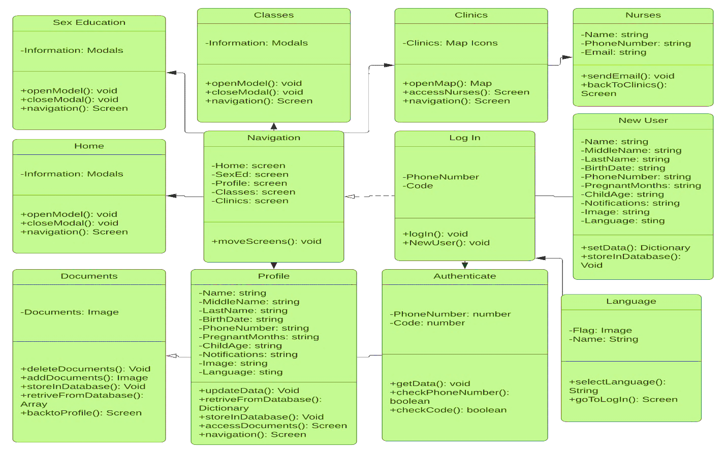

*Architecture Diagram*

*Sequence Diagram*

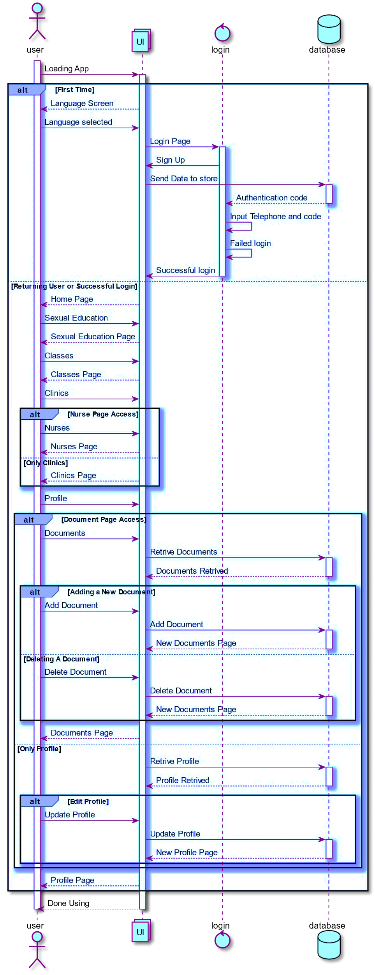

## *Use Case Diagram*

## Appendix B - User Interface Design*

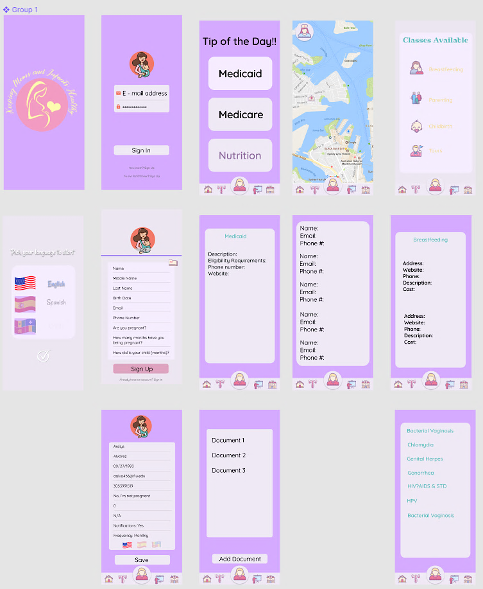

* This design was slightly modified to fit our personal preferences and for easy implementation

## Appendix C - Sprint Review Reports

**Sprint 1**

**Date:** 9/23/2019

**Product Owner**: Jean Hannan

Stories Completed in Sprint

|  |  |  |  |  |
| --- | --- | --- | --- | --- |
| Story ID | Story Title | Status | Assigned To | Hours |
| 49 | Project Outline | Closed | Arelys | 21.3 hours |
| 43 | Skeleton for Project | Closed | Andy | 18.6 hours |
| 29 | Wireframe | Closed | Arelys and Andy | 8.8 hours |

Stories NOT Completed in Sprint

|  |  |  |  |  |
| --- | --- | --- | --- | --- |
| Story ID | Story Title | Status | Assigned To | Hours |
| 30 | Setup Environment | Moved | Arelys and Andy | 37.9 hours |

**Sprint Goal**: Were all sprint goals achieved?

The environment setup was not completed with all the task. One task was not completed, and the user story was pushed to Sprint 2, there was also a bug.

**Total Velocity**: 86.6 hours

**Sprint 2**

**Date**: 10/7/2019

**Product Owner**: Jean Hannan

Stories Completed in Sprint

|  |  |  |  |  |
| --- | --- | --- | --- | --- |
| Story ID | Story Title | Status | Assigned To | Hours |
| 61 | Reorganize wireframe | Closed | Arelys and Andy | 8 hours |
| 67 | CDC API | Closed | Andy | 2 hours |
| 39 | Setup Database | Closed | Arelys | 14 hours |
| 55 | Profile Creation | Closed | Andy | 30.3 hours |

Stories NOT Completed in Sprint

|  |  |  |  |  |
| --- | --- | --- | --- | --- |
| Story ID | Story Title | Status | Assigned To | Hours |
| 54 | Authentication | Moved | Arelys | 18 hours |
| 30 | Setup environment | Moved | Arelys and Andy | 11 hours |

**Sprint Goal**: Were all sprint goals achieved?

The environment setup was not completed with all the tasks, moved to the future sprint. Bug needs more work and it will be moved to future sprint along with Authentication where one task was not completed.

**Total Velocity**: 83.3 hours

**Sprint 3**

**Date**: 10/21/2019

**Product Owner**: Jean Hannan

Stories Pulled into Sprint

|  |  |  |  |  |
| --- | --- | --- | --- | --- |
| Story ID | Story Title | Status | Assigned To | Hours |
| 86 | Add user photo to profile creation | Closed | Andy | 23.5 hours |
| 82 | Push sign up info to database | Closed | Arelys | 18.8 hours |
| 81 | Continue backend part of authentication Process | Closed | Arelys | 7 hours |
| 76 | Language requirement | Closed | Andy | 10 hours |
| 34 | Link to health resources | Closed | Andy | 22.3 hours |

**Sprint Goal**: Were all sprint goals achieved?

All user stories and plans were completed during this sprint.

**Total Velocity**: 81.6 hours

**Sprint 4**

**Date**: 11/4/2019

**Product Owner**: Jean Hannan

Stories Pulled into Sprint

|  |  |  |  |  |
| --- | --- | --- | --- | --- |
| Story ID | Story Title | Status | Assigned To | Hours |
| 95 | Finish last details of authentication and sign up | Closed | Arelys | 18.5 hours |
| 92 | Review and reorganize the work | Closed | Andy | 42.7 hours |

Stories NOT Completed in Sprint

|  |  |  |  |  |
| --- | --- | --- | --- | --- |
| Story ID | Story Title | Status | Assigned To | Hours |
| 98 | Figure out a way to retrieve user information from DB | Moved | Arelys | 25 hours |

**Sprint Goal**: Were all sprint goals achieved?

Database is producing problems and tasks will be pushed for continue work in sprint number 5.

**Total Velocity**: 86.2 hours

**Sprint 5**

**Date**: 11/19/2019

**Product Owner**: Jean Hannan

Stories Pulled into Sprint

|  |  |  |  |  |
| --- | --- | --- | --- | --- |
| Story ID | Story Title | Status | Assigned To | Hours |
| 119 | Redo navigation | Closed | Arelys | 18 hours |
| 98 | Figure out a way to retrieve user information from DB | Closed | Arelys | 21 hours |
| 109 | Add clinics screen and functionality | Closed | Arelys | 10 hours |

Stories NOT Completed in Sprint

|  |  |  |  |  |
| --- | --- | --- | --- | --- |
| Story ID | Story Title | Status | Assigned To | Hours |
| 108 | Add classes screen and functionality | Moved | Andy | 34.5 hours |
| 79 | Add functionally to documents view | Moved | Andy | 14.5 hours |

**Sprint Goal**: Were all sprint goals achieved?

There were some tasks not competed when it came to the classes screen and documents screen, moved to sprint 6.

**Total Velocity**: 98 hours

**Sprint 6**

**Date**: 12/2/2019

**Product Owner**: Jean Hannan

Stories Pulled into Sprint

|  |  |  |  |  |
| --- | --- | --- | --- | --- |
| Story ID | Story Title | Status | Assigned To | Hours |
| 1 | Home page functionality | Closed | Andy | 6 hours |
| 2 | Perfect UI design of the app | Closed | Arelys and Andy | 29.5 hours |
| 3 | Finalize clinics screen | Closed | Arelys | 19 hours |
| 4 | Continue fixing navigation | Closed | Arelys | 31.1 hours |
| 5 | Add classes screen and functionality | Closed | Andy | 12 hours |
| 6 | Add functionality to documents view | Closed | Andy | 10 hours |
| 7 | Set up environment | Closed | Arelys | 0 hours |

**Sprint Goal**: Were all sprint goals achieved?

All tasks where completed for this sprint.

**Total Velocity**: 85.6 hours

## Appendix D

# User Manual

With the current version of the application, all users have the same functionality.

The first screen that shows up when a user opens the application is the Language selection screen, once the user set their preferred language, they go to the next screen which is a tutorial on how to use the app and the different features that the app has. After the tutorial the user is presented with the log in screen, in this screen the user can log in or create an account if is the first time that the user uses the application. After and account is successfully created the user is taken to the Log In screen again where they can sign into the app with the code they received and their phone number. Upon logging into the application, the user is greeted with the home screen. A navigation bar at the bottom of the screen allows the user to navigate to their profile, the classes available, the sexual education screen and the clinics screen. The home screen shows information related to the programs available to them, which includes “Women, Infants, and Children”, “Medicaid”, and the “Heartbeat Pregnancy Help Medical Clinic” relevant to a user. The log in process is a single sign in process, once the user is logged in and closes the app, when they open the app again, they won’t need to log in again, they will be taken directly to the home screen.

***Log In***

Start the application. Enter the phone number and the code received and click submit. If valid, you will be taken to the homepage.

***Editing user information***

On the bottom tab navigator, navigate to the user account. Once on the user account, edit the desired information and change the language if needed, after all the changes has been done, click save. The information will be updated in database and the correct information will be displayed on the profile.*

***Store a document***

Within the user account, on the right side of the header tab, tap on the “files” icon and you will be taken to the documents screen where you will have the option to take a picture of your document or get the document from the Gallery of your phone.

***Inspect the classes available***

On the bottom tab navigator, navigate to the classes screen, here you will be presented with the different classes available, click on the desired class and you will be presented with more information about that class.

***Inspect the sexual education information***

On the bottom tab navigator, navigate to the sex ed screen, here you will be presented with different sexually transmitted diseases, click on the desired title and you will with a view of the CDC website with more information about the selected disease.

*V****iew the clinics available***

On the bottom tab navigator, navigate to the clinics screen, you will be asked to share your location. Once you accept to share your location you will be presented with a map showing you where the different clinics that we work with are located. Click on the desired clinic to show the name of the clinic and their phone number. In this screen you will be able to see your current location and consequently you will see how far await is the clinic from you.

***View the nurse practitioner information***

On clinics screen, that shows the map, on the top left corner, tap the “nurse” icon. You will be taken to the nurse practitioner screen that shows the information of all the nurses that we work with so you will have the possibility to contact the nurse of your preference to ask any question you may have.

***Log Out***

Within the user account, on the right side of the header tab, tap on the “door with the arrow” icon and you will be logged out of the application and taken to the language selection screen, to repeat the sig in flow.

# Installation/Maintenance Document

I – Prerequisites:

* have GIT installed on the computer
  + https://git-scm.com/
* Install yarn or npm
* https://yarnpkg.com/en/
* https://www.npmjs.com/

As a Side Note

* We choose to use npm.
* Also note that yarn and npm shouldn’t be used at the same time so never have a (package-lock.json) and (yarn.lock) file at the same time.
* The following steps where followed to run the application on a MacBook Air using Visual Studio Code. However, the steps are as generic as possible and anyone should be able to do the same on any operating system.

*Step 1:*

Open up Visual Studio Code and used the integrated command line to access the file where you will like to clone the project into.

TYPE → cd Desktop/<the name of the folder where you will clone the project into>

*Step 2:*

Visit the bitbucket project’s repository and copy the HTTP cloneable link to download the file. This link might change with time

*Step 3:*

Use Visual Studio Code integrated terminal to clone the project into your desired directory. Inside the directory

TYPE → git clone <the link to the project>

*Step 4:*

Now that the project has been cloned, open the project in Visual Studio Code to view the file structure.

*Step 5:*

Now that the project has been clone you will need to access that directory in the integrated terminal

TYPE → cd React%20Native%20App/React-Native-App

*Step 6:*

Once you’re inside the React-Native-App directory of the you will need to install the backend node dependencies.

TYPE → npm install

*Step 7:*

On the same directory, you will also need to install the expo cli on your computer to be able to run the project.

TYPE → npm install expo-cli --global

*Step 8:*

On your phone you will need to install expo client

|  |  |
| --- | --- |
| **Google Play**  /var/folders/1r/k10sym5s2yvgl4fdr5rtlt200000gn/T/com.microsoft.Word/Content.MSO/4F18F7F8.tmp | **Apple App Store**  /var/folders/1r/k10sym5s2yvgl4fdr5rtlt200000gn/T/com.microsoft.Word/Content.MSO/B6F238C6.tmp |

*Step 9:*

Once the backend node modules have been installed, and you have the expo client installed on your phone, you will need to run the application locally so that you can view it on your phone. You can do it in two different ways, either

TYPE → npm start or TYPE → expo start

Git might have password: b6obxkksjf64amp3nn2zubf4xc2h7jmvof32cslrjihknbwmyxaa

For the Maintenance portion of this document please refer to the video portion of Maintenance.

*this is the desired behavior; this is not currently working due to database complications and time constraints

# Shortcomings/Wishlist

### Profile Information Retrieval

The Firebase posed obstacles in retrieving the information the user inputted to sign up. It did not retrieve it back to the profile screen when called upon. This would have helped the user maintain a personal account that can be edited. The user can’t change information which hinders other features.

### Document Information Retrieval

The Firebase posed obstacles in retrieving the information the user inputted to documents. It did not retrieve it back to the documents screen when called upon. This would have helped the user maintain the documents uploaded or edited. The user can’t add or delete pictures which hinders the feature.

### Access Phone Drives

The documents session was useful for uploading photos taken or from gallery. However, access to phone drives and other file types would be a great Wishlist addition for future versions. This would help maintain more document types inside the app.

### Nurse Practitioner Profile

The user would be given an option to register as a nurse practitioner so they could add their contact information to the nurse’s screen. This would help increase the nurse’s available to contact list and bring more useful features to the app.

### Notifications

The user would receive notifications based on the plan they selected of weekly, bi-weekly, or monthly. Notifications provided by PO.

# References

[1] Figma Documentation. (n.d.). Retrieved December 06, 2019, from <https://www.figma.com/>

[2] Azure Documentation. (n.d.). Retrieved December 06, 2019, from <https://dev.azure.com/>

[3] React Native Documentation. (n.d.). Retrieved December 06, 2019, from <https://facebook.github.io/react-native/docs/getting-started>

[4] Expo Documentation. (n.d.). Retrieved December 06, 2019, from <https://docs.expo.io/versions/latest/>

[5] Photoshop Documentation. (n.d.). Retrieved December 06, 2019, from <https://helpx.adobe.com/photoshop/user-guide.html>

[6] Git Documentation. (n.d.). Retrieved December 06, 2019, from <https://git-scm.com/doc>

[7] Firebase Documentation. (n.d.). Retrieved December 06, 2019, from <https://firebase.google.com/docs>

[8] JavaScript Documentation. (n.d.). Retrieved December 06, 2019, from <https://devdocs.io/javascript/>

[9] React Navigation Documentation. (n.d.). Retrieved December 06, 2019, from <https://reactnavigation.org/docs/en/getting-started.html>